Bioc 404 – Biophysical Chemistry
April 03, 2006
Benoit Lamairesse

X-Ray Crystallography:
(Dr. Cygler)

Lecture 5

So – we know that electron density can be derived from the inverse Fourier transform of the scattering amplitude over all possible directions of scattering vector S:

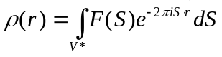

Because of the shape function, the scattering from a regular lattice is only nonzero if 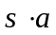 (h), 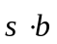 (k), and 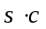 (l) are integers. Therefore, instead of using an integral, we can use the sum of the terms over all values of h, k, and l.

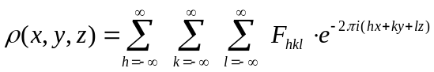

x, y, and z are therefore coordinates for e- density, & F is the scattering vector for the whole lattice in the direction described by h, k, and l.

The physical meaning of increasing h, k, and l:
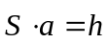, and (the dimension of the repeating unit in the lattice) is fixed, so increasing h increases the size of the scattering vector, .

Because 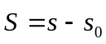, a bigger also means increasing the size of the angle between the incident and scattered radiation…
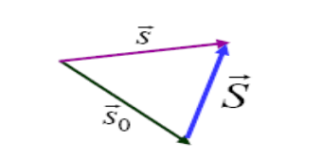

It is only feasible to measure the scattering angle to a certain degree, because:
- Crystals are only approximations of regular lattices. They propagate to a high degree, but at some point they break down – an irregularity in the lattice – and then the crystal resumes its lattice structure. In this case, the inherent faults in the crystal (which vary from crystal to crystal), cause our scattering measurements to be thrown off a little, and prohibit our calculating the exact electron density map of our molecule. This inherent error eventually overcomes the level of precision obtained by calculating electron density through the use of higher and higher values of h. (and therefore increasing scattering angle). This is similar to the principle of significant digits… it’s no good to calculate a yield to 6 significant digits if your original sample was measured only to 2.

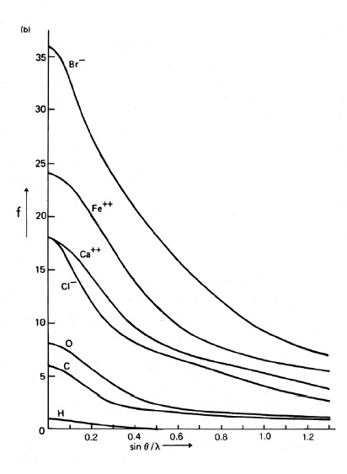
- Remember:
When 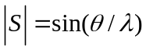 increases, so does the scattering of individual atoms (see right), which means their sum, which is the scattering of the molecules, also falls off… The intensity of the scattering will decrease, and the darkness of the scattered points we perceive on the film will do likewise. At higher scattering angles, the points become unperceivable, which means we lose higher-order terms.

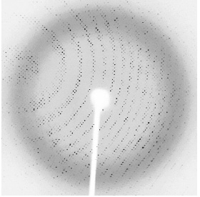
Below is an example of a diffraction pattern on a film. Note the loss of intensity towards the edges.

- The temperature factor B also increases the loss of scattering intensity as a function of the magnitude of, amplifying the above phenomenon, and contributing to our loss of higher-order terms.

The loss of higher-order terms is consequential. It means we are only able to calculate an approximate electron density, and that our resolution is reduced. The following formula relates to our resolution:

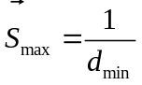

…higher-order terms of h, k, and l result in greater, increasing the resolution. Similarly, loss of higher-order terms results in lower resolution.

At 1Å resolution, we can start placing hydrogens (they only have 1 electron so diffract very little)
At 2Å resolution, we can still properly guess the placement of individual atoms.
At 3Å resolution it becomes a little difficult to determine what is where, as the electron clouds start to merge into smudged blobs. Overall structure is distinguishable, but individual atoms are hard to place.
NOTE 1: We measure intensity on our screen, but intensity is proportional to the square of the amplitude:

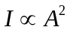

That means a 50% decrease in amplitude of the x-rays as a result of the above phenomena results in a 75% decrease in intensity. Intensity therefore falls off very quickly. Also – the intensity contains only information about the modulus and nothing about the phase… and issue that will be addressed in a later lecture.

NOTE 2: The density of the dark spots on the film is proportional to the size of the unit cell. Large unit cells produce dense points whereas small unit cells produce weak spots. A protein unit cell being rather large will produce dark, well-defined points.

Crystallization:

Crystallization, first of all – is more of an art than a science. Many different parameters can be played with, everything depends on the individual protein, and technique is VERY important to ensure the best possible crystal formation. Proper crystal formation is of utmost importance, because a good sample will provide the best results.

Firstly:
We need LOTS of protein. This means that when this technique started, the only proteins we were able to study were those naturally produced in large quantities that we could properly isolate. Now with genetic engineering, we can use recombinant DNA to over express target proteins in various host animals.

Secondly:
We need to be able to easily purify/separate the protein from the host cell. This is best performed through the use of protein tags the likes of GST and histidine tags, and then performing affinity chromatography. This requires that our recombinant DNA also include a tagging sequence.

Thirdly:
The tag is not part of the original protein, which means it would change our diffraction results. We therefore need to remove it somehow. The best way is through the use of highly specific proteases (highly specific because we want to ensure they leave our protein fully intact, without cleaving anything.) Example: 3-c protease, which has a 6-AA target site. This also means that our recombinant protein’s DNA must include a sequence coding for the cleavage site between the tag and the original protein.

Fourthly:
Further purification of the protein may be done by various means (think back to before the midterm). Just remember- the purer your sample, the easier the crystallization.

So… How do we crystallize?
Crystallization may be done by a few methods. The essentials are presented in the figure below.
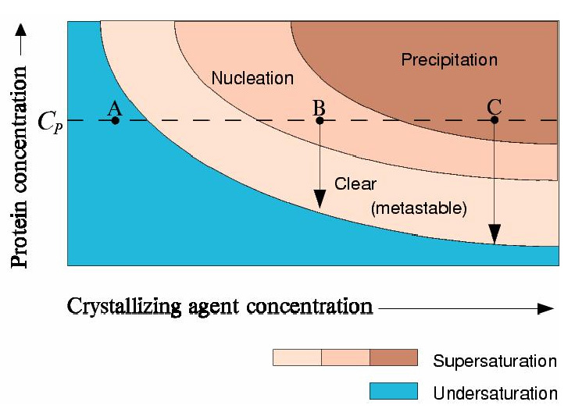

Precipitation may be done by evaporating solvent, or adding crystallizing agents - which reduce the solubility of the protein in solution and bring it closer to saturation.

Starting the crystallization process (nucleation) is the hardest part. Once a solution is supersaturated, there’s a period of time where the solution remains relatively stable. The freely-tumbling molecules in solution have to overcome a little entropy before they can align properly in an ordered, bound manner. Once the Crystal is nucleated, it the crystal formation propagates at a reasonable speed.

Note however that precipitation of the protein out of solution lowers the concentration… so evaporating enough solvent may require some time before enough protein has precipitated out of solution into a sizeable crystal.

It is important to note that the faster the process is carried out, the less time molecules have to properly align, and what will happen is simple disordered precipitation instead of ordered crystal formation. This means one must be careful not to rush the procedure.

Also – remember that most proteins are found in solution and require water to retain the proper structure. That said – removal of water to increase the protein concentration in solution is therefore not recommended so as to avoid denaturing of the protein. This is what makes the use of other agents to help in crystallization important. These include:
- salts (sulfates, phosphates)
- polyethylene glycols (very powerful agents)
- organic solvents
Modifying the pH of the solution is also helpful (remembering that proteins are least soluble in their uncharged state… at their pI.)

Methodology:

There are two major crystallization techniques. The “Hanging Droplet” and the “Batch” methods.

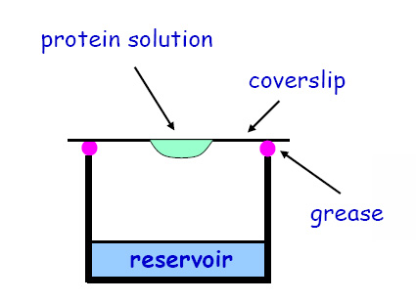
Hanging Droplet:
This method requires the formation of a closed system consisting of a reservoir (~100μL) with a concentration of precipitating agent above that required for precipitation of the protein solution, and a drop of protein solution (~1-5 μL, and with a concentration of precipitating agent below what is required for precipitation) hanging from the top of the container. With time, the system will slowly equilibrate via the net evaporation of solvent from the protein solution, or the net migration of precipitating agent from the reservoir to the protein solution (if the agent is volatile), and as the protein or precipitating agent concentration increases, crystal formation will result.
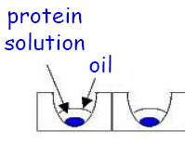
Batch:
The Batch Method consists of placing a drop of protein solution (complete with precipitating agent) in a small well, and covering it with a drop of oil. The oil drop will considerably slow down evaporation, but not entirely stop it. This will also result in a slow, gradual increase in both protein and precipitating agent concentration, and allow for proper crystal formation.

These methods have now been automated. Instruments can perform crystal growth with various volumes of drops, ranging from 50 nL to 1 μL or more. Smaller drops generally are better because of:
- The dynamics of crystal growth (Dr. Cygler didn’t elaborate on this)
- Smaller volumes means more trials. This is important especially when the protein you are studying is very expensive.

Dr. Cygler says the usual drop volume we use is 500-700nL, simply because the quantities of protein are rarely an issue for types of proteins commonly studied.

To use one of these instruments, you have an array of wells each with different concentration of precipitating agent, place your drop of solution in the appropriately labeled location, and the instrument will complete the process, storing your wells safely and taking periodic pictures. You can then check the pictures on your computer to monitor crystal formation.

Once a set of conditions has been identified as inducing crystal growth, you want optimize the crystallization, which is done by playing with the crystal growth conditions a very little bit (pH, concentration of protein/crystallizing agent, etc…) in order to get nice, large crystals.

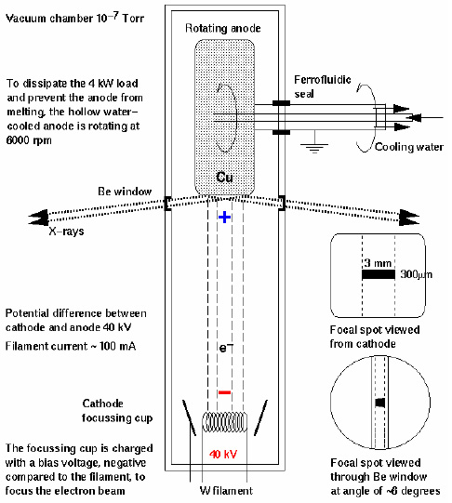
Generating X-rays:
X-rays can be generated in-lab by the setup at right:

Electrons are highly accelerated through an electric field, striking the metal. When they hit the metal they slow down (remember deceleration is just negative acceleration, so slowing down of electrons emits electromagnetic radiation), and X-rays are emitted.

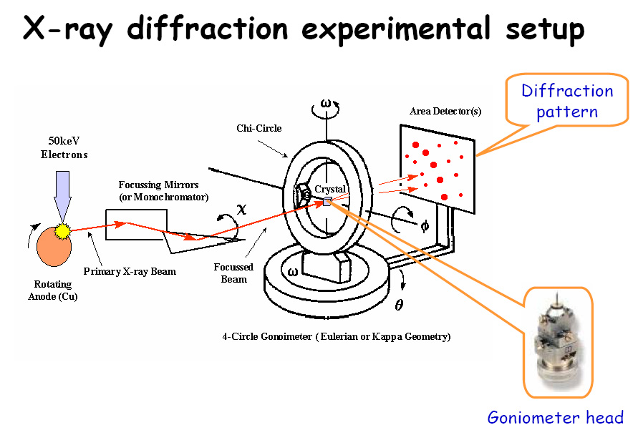
X-rays are then passed through a monochromator (to select the proper wavelength), and then focused on the crystal (typical size ~0.2mm diameter), which lies fixed on its rotatable support, the goniometer head. (Diagram below)

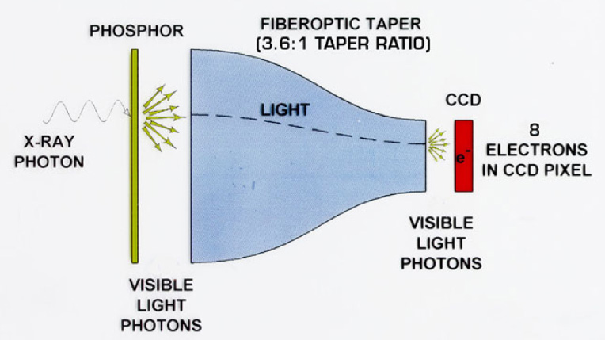
CCD Detector:
(Only for information purposes…)

The CCD detector is what enables us to detect X-rays.

X-rays hit a phosphor screen, which emits visible light at the point(s) of incidence of X-ray radiation, the newly emitted light is tapered into a CCD (Charge-Coupled Device) via a fiber optic taper, and the CCD detects the visible light, sending a signal.

A typical size is 20cm x 20cm.

Synchrotrons:
X-rays generated in the lab are generally pretty weak. Synchrotrons (huge installations several hundred meters in diameter) accelerate electrons in a circular path, generating powerful X-rays.

3 of the larger synchrotrons are:
- ESRF (Grenoble, France)
- APS (Argonne, USA)
- Spring-8 (Himeji, Japan)

X-Ray Diffraction Experimental Setup:

The experimental setup of an X-ray diffraction experiment, appropriately labeled, look like this:
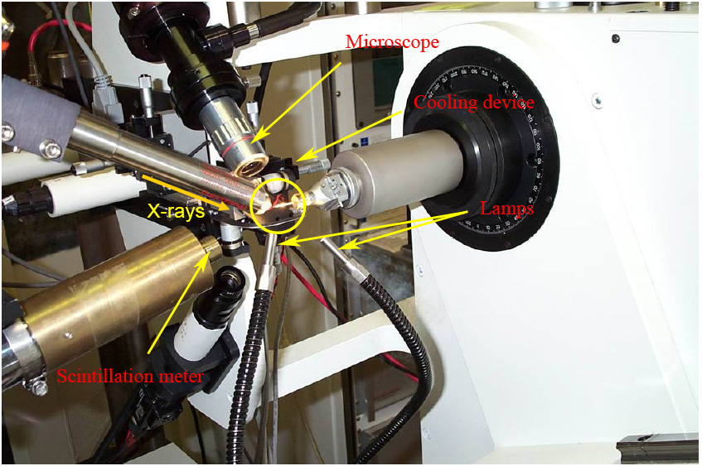

The cooling device is there to cool the crystals down to ~100K in order to slow down thermodynamic vibration of the molecules, as well as the destructive chemistry of X-rays. (X-rays produce large amounts of free radicals… cooling down the crystals helps maintain them longer.)

